Samuel Olatunde
Colab link
Introduction
The goal of this project is to gain hands-on experience with fundamental machine learning concepts, including data analysis, processing, visualization, modeling, evaluation, and reporting. To achieve this, we addressed the problem of predicting cotton crop yield using seasonal canopy cover data from cc2.csv. The dataset combines identifiers, experimental factors, and measurements. Columns such as row, col, rep, line, and grid describe the experimental layout, while irrigation indicates treatment. Row specifies planting rows, and Weight per row (lbs) represents yield in pounds, referred to as “yield” throughout this report. The canopy cover columns (cc_0412 to cc_0812) capture crop coverage at various dates, reflecting plant growth dynamics that can be linked to final yield. Since the dataset focuses on canopy cover and yield, the primary objective is to build models that predict yield from canopy cover measurements alone.
Methodology
This section outlines the tools and processes used to implement the project.
Tools
The project was implemented in Python using the Google Colab environment. Several Python packages were central to analysis, visualization, and modeling:
- pandas: For data manipulation and storage.
- dataframe_image: To convert and save DataFrames as images for reporting results.
- matplotlib & seaborn: For scatter plots and box plots during exploratory analysis.
- scikit-learn: To provide baseline machine learning models and utilities for preprocessing, data splitting, and evaluation.
- joblib: For saving and reloading trained models.
- os: For directory and file management.
Process 1: Data Analysis
The dataset, containing 875 entries, was loaded into a pandas DataFrame, and the column Weight per row (lbs) was renamed to yield for simplicity. Yield values ranged from 0.0 to 15.65, with a mean of 6.62 and a median of 6.51, indicating a fairly symmetric distribution. Of the entries, 425 exceeded the mean and 437 exceeded the median, showing balance around the center. Most values clustered near 6.5–6.6, with fewer at the extremes. Only three rows had a yield of 0, which corresponded to canopy cover values that never peaked (maxing out between 30 and 60), making the 0 yield reasonable. Finally, the dataset contained 17 rows with missing values, of which 10 had at least one missing entry.
Process 2: Data Visualization
To explore potential trends, we generated scatter plots of yield against each canopy cover variable, box plots for all canopy cover features, and computed the Pearson correlation between canopy cover and yield.
From visual inspection, no clear linear, quadratic, or logistic relationship emerges — data points appear clustered without a distinct trend. Early canopy cover dates (e.g., cc_0412) show clusters near zero coverage, which shift rightward as the season progresses, reflecting growth. Once peak coverage is reached, points shift back toward the left, indicating canopy decline. This pattern mirrors the natural crop lifecycle: emergence, growth, maturity, and senescence.
Box plots reveal frequent lower outliers, suggesting that some plots experienced unusually low canopy coverage. These likely reflect natural variability in crop growth, as canopy expansion is rarely uniform across all plants. Refer to the Colab to view scatter and box plots.
The Pearson correlation values show yield is moderately correlated with canopy cover between mid-May and late June (cc_0516–cc_0623). The strongest correlation occurs at cc_0623 (0.527), suggesting mid-season canopy cover is a moderately good predictor of yield.
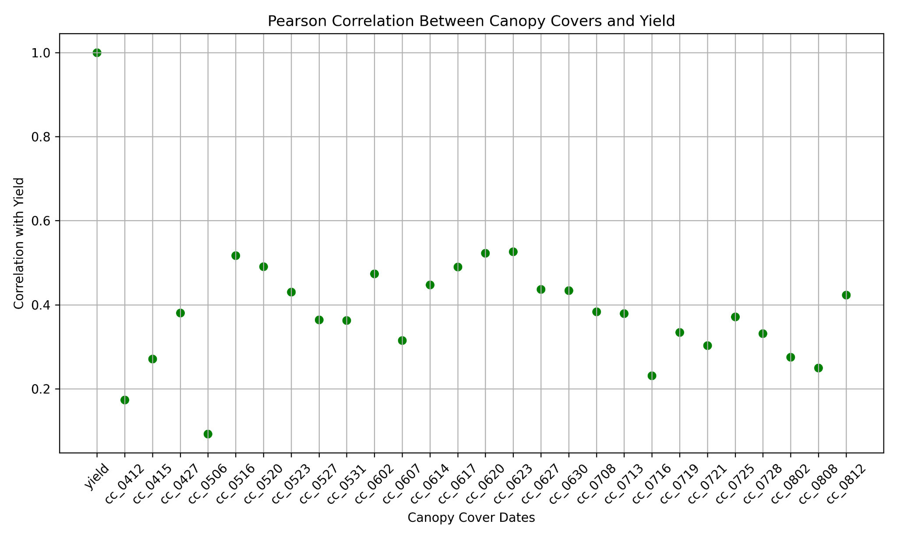
Before modeling, missing values were imputed using scikit-learn’s IterativeImputer, which applies a multivariate regression-based approach. We used linear regression as the estimator, limited imputations to 50 iterations, considered the 4 nearest features, constrained values between 0 and 100, and skipped columns without missing data.

Process 3: Modeling
We used three models:
- Linear Regression – A simple, interpretable baseline for linear trends.
- K-Nearest Neighbors (KNN) – Useful for capturing non-linear patterns.
- Random Forest – Robust to noise and effective for modeling complex, non-linear relationships.
Models were trained, tuned, and evaluated on two datasets:
- Non_FS – All 27 canopy cover features included.
- FS_1 – Features with Pearson correlation < 0.4 removed, leaving 11 features.
Both datasets were split into training, validation, and test sets. KNN and Random Forest received primary focus for hyperparameter tuning. The table below lists the tuned hyperparameters and their search ranges for both Non_FS and FS_1 datasets.

KNN and RF Hyperparameter Grid
Model | Hyperparameter | Non_FS | FS1
KNN | n_neighbors (k) | [15,16,17,18,19,20,29,99,201,109] | [15,16,17,18,19,20,29,99,201,109]
KNN | weights | [‘uniform’,’distance’] | [‘uniform’,’distance’]
Random Forest | n_estimators | [80,100,300,400,500] | [40,60,80,100,500]
Random Forest | max_features | ['sqrt','log2', 1.0,3,15,18,24] | ['sqrt','log2', 1.0,2,3,4,5,6,7,8,9,10]

Model Tuning
Before hyperparameter tuning, directories were created (via the os package) to store trained KNN and Random Forest models in an organized way. For both models, tuning was performed on the Non_FS (27 features) and FS_1 (11 features) datasets. Performance was assessed using Mean Squared Error (MSE)—chosen to penalize the outliers discussed earlier—and R² score, which quantifies how well the models explain yield variation.
For K-Nearest Neighbors (KNN), we defined a range of k values (number of neighbors) and trained two variants for each: 'uniform' (equal neighbor weight) and 'distance' (closer neighbors weighted more). Each variant was trained on the training set and evaluated on the validation set. Results—including hyperparameters, MSE, R², and file paths—were stored in a structured format. Models were saved with unique filenames using joblib for traceability. The best KNN configuration for each dataset was chosen based on validation MSE.
For Random Forest, we exhaustively tuned combinations of n_estimators (trees) and max_features (features per split). Each model was trained and validated using MSE and R². Results were stored and sorted by validation MSE to identify the best configuration. Trained models were saved with descriptive filenames for reproducibility and later evaluation.All models were trained with a fixed random_state = 17 to ensure reproducibility.
Process 4: Evaluation
Evaluation was carried out on the test set for all models.
- Linear Regression: Since it has no hyperparameters, training and validation splits were combined to maximize learning. Final models were trained on both Non_FS and FS_1 datasets and evaluated on the test sets using MSE and R².
- KNN: The best-performing models from validation (one from each dataset) were loaded from storage and evaluated on their respective test sets. Predictions were generated, and performance was assessed with MSE and R². Hyperparameters (e.g., k, weighting scheme) were also recorded for reporting.
- Random Forest: The top models from validation were similarly reloaded and evaluated on their test sets. Predictions were compared using MSE and R², and key hyperparameters (n_estimators, max_features) were documented.
All evaluation results were compiled into structured tables for comparison and inclusion in the final report.
Results and Discussions
Linear Regression

Fig 1: Linear Regression Performance Across Test Sets
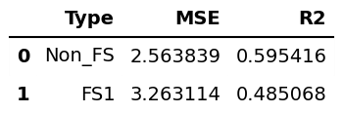

Fig 1 shows the MSE and R² values for the Linear Regression model evaluated on the Non_FS and FS_1 test sets. Performance is noticeably better without feature selection, indicating that the reductive feature selection reduced the model’s accuracy.

K-Nearest Neighbors (KNN) Model
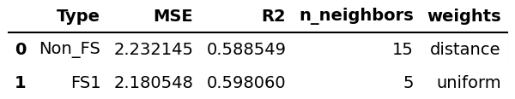
Fig 2A: KNN Hyperparameter Tuning Results

Fig 2A shows the best-performing KNN model configurations found during tuning. The Non_FS dataset required more neighbors (15) and used distance-based weights, while the FS_1 dataset achieved better performance with fewer neighbors (5) and uniform weights. In terms of MSE, R², and computational efficiency, the FS_1 configuration outperformed the Non_FS one. Thus, the best KNN model is the FS_1 version with 5 neighbors and uniform weighting. The next step is to check if this trend holds on the final test set.

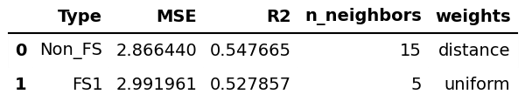
Fig 2B: Test Set Evaluation Results for KNN Models

Fig 2B presents the final evaluation of the KNN models. Both the Non_FS and FS_1 configurations show a substantial increase in MSE compared to validation, with FS_1 performing worse despite its superior results during tuning. This decline is likely influenced by outliers in the dataset. The R² scores further indicate that both models explain only about 50% of the variability in yield, representing a notable reduction in performance relative to the tuning phase.

Random Forest Models

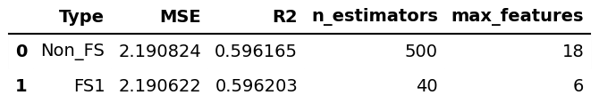
Fig 3A: Random Forest Hyperparameter Tuning Results

Fig 3A shows the Random Forest tuning results. The Non_FS model achieved its best performance with 500 trees and 18 features per split, while the FS_1 model performed best with 40 trees and 6 features per split. Although both models performed comparably, FS_1 achieved slightly lower error with improved computational efficiency due to fewer trees and features.

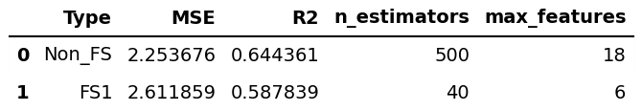
Fig 3B: Test Set Evaluation Results for Random Forest Models

Fig 3B shows the test set results for the Random Forest models. Both models exhibit higher MSE values compared to tuning (Fig. 3A), with Non_FS increasing slightly and FS_1 increasing a bit more. Interestingly, the R² score for Non_FS improves relative to tuning, indicating that this model explains more of the variability in yield on the test set than it did on the validation set.

Conclusion
Overall, the Random Forest model trained with all features (Non_FS) using 500 trees and 18 features per split proved to be the best-performing configuration. It showed the smallest increase in MSE from tuning (2.1908) to evaluation (2.2537), a difference of only 0.0629, achieved the lowest MSE across all evaluated models, and demonstrated an increase in R² from 0.5962 to 0.6444. These results suggest that the Non_FS Random Forest generalizes better than the other models, making it a strong candidate for yield prediction. Future experiments could further refine performance by tuning additional hyperparameters or exploring alternative feature selection strategies. Specifically, our tuning table (see Colab) suggests that using 100 trees yields performance similar to 500 trees, so reducing the number of trees may preserve accuracy while significantly lowering computational cost.

